**CS- Lab 10**

Name- Sakshi Patil

TY-IC_C, Batch 3

Roll no-3

GR no- 11910968.

**Title- Implement RSA using virtual lab take relevant screen shots and upload the same.**

**Snapshots-**

**1)**

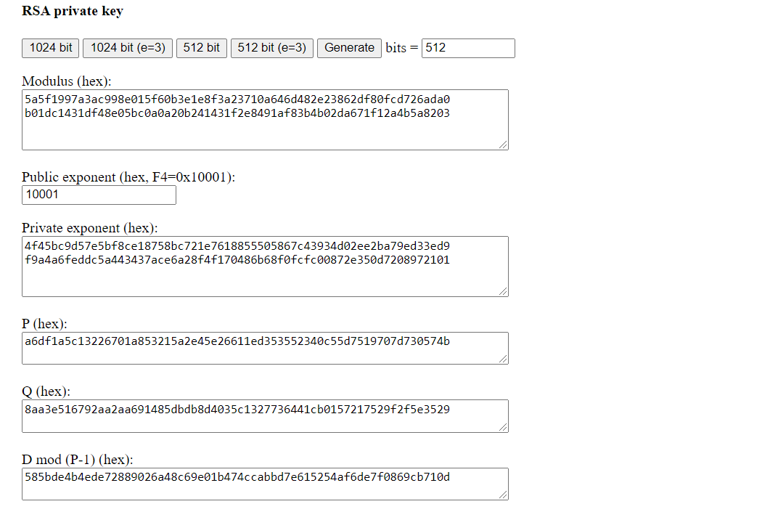

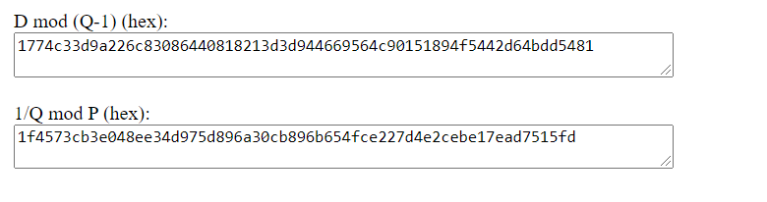

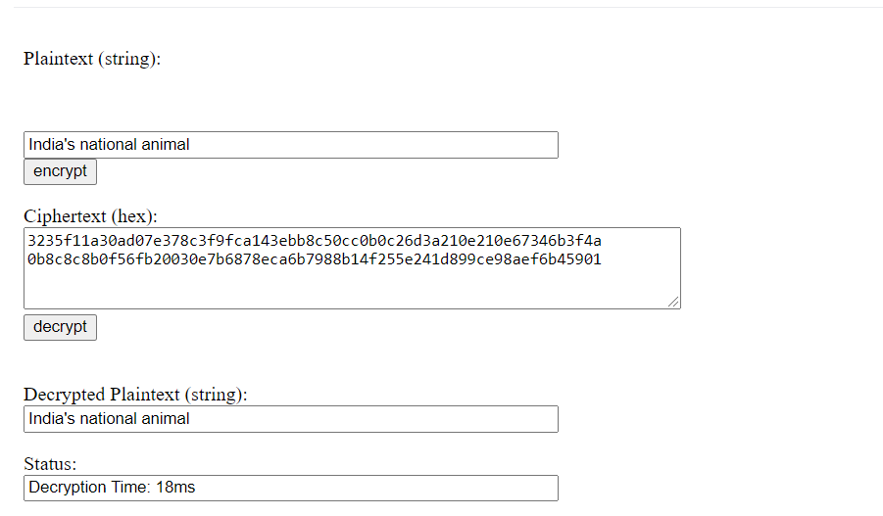

**2)**

